**Error:** Page load failed with error: The resource could not be loaded because the App Transport Security policy requires the use of a secure connection.

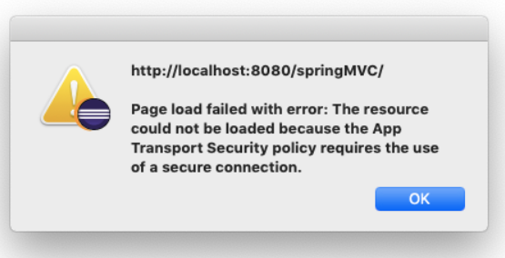

**Solution**

This is an issue on MacOS with non-signed binaries.

you can do the following to avoid the error

Change the default browser to an external browser.

steps

1) click on the eclipse icon in the top menu

2) Select Preferences

3) search for browser in the preferences

4) Select any other browser present in the system

Also, please check the screenshots below.

